UNDERWATER COMMUNICATION RESEARCH

<http://www.ieee.org/organizations/pubs/newsletters/oes/html/spring06/underwater.html>

Underwater communication challenges:

* Frequency-dependent propagation loss
* Severe multipath
* Low propagation speed of sound.

**Frequency-dependent propagation loss:**

Path loss is a function of a coefficient k whose value is usually between 1 and 2, an absorption factor a(f) that is a function of frequency, and distance d.

A=dka(f)d

At large distance, around 100km, this becomes a big problem and results in an available bandwidth of about 1kHz. For our application, we will be at short distances, much less than 1km, and will not be limited in frequency by propagation loss, but by the transducer.

**Multipath :**

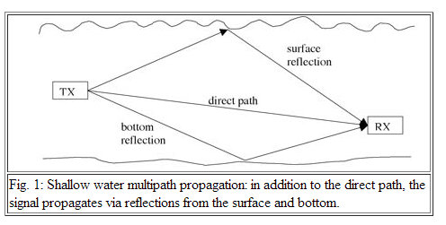

This will be an issue for us, because for our project, and in the application the AUV would be used for, it would be in relatively shallow waters. In shallow waters, reflection occurs from the surface of the water and from the bottom.

Source for purchasing components:

<http://www.benthowave.com/products/BII-8080TR.html>